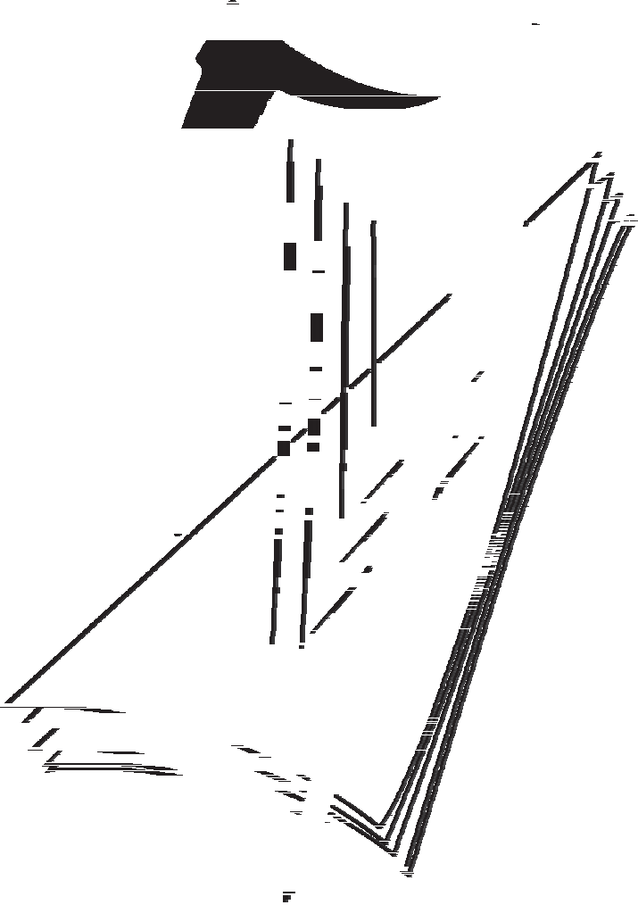
2013. M80BC
Coimisiún na Scrúduithe Stáit
State Examinations Commission

Leaving Certificate Examination, 2013

Design & Communication Graphics
Ordinary Level
Sections B and C (180 marks)
Wednesday, 19 June
Afternoon, 2:00 - 5:00

This examination is divided into three sections:
SECTION A (Core - Short Questions) SECTION B (Core - Long Questions)
SECTION C (Applied Graphics - Long Questions)
- Four questions are presented.
SECTION A • Answer any three on the accompanying A3 examination paper.
- All questions in Section A carry 20 marks each.
- Three questions are presented.
SECTION B • Answer any two on drawing paper.
- All questions in Section B carry 45 marks each.
- Five questions are presented.
SECTION C • Answer any two (i.e. the options you have studied) on drawing paper.
- All questions in Section C carry 45 marks each.

General Instructions:
- Construction lines must be shown on all solutions.
- Write the question number distinctly on the answer paper in Sections B and C.
- Work on one side of the drawing paper only.
- All dimensions are given in metres or millimetres.
- Write your Examination number in the box provided on section A and on all other sheets used.

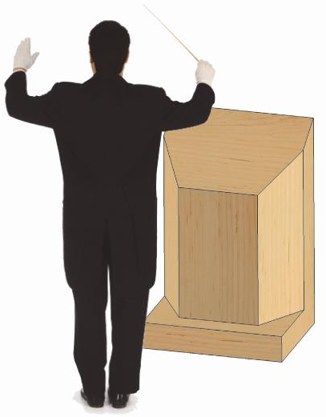
B-1. The 3D graphic on the right shows a music stand and conductor.
SECTION B - Core
Answer any two questions from this section on drawing paper

Fig. B-1 shows an isometric view of a model of the stand.

- Draw an elevation of the stand looking in the direction of the arrow.

- Draw a plan projected from the elevation.

- Draw an end view of the stand.

- Draw an auxiliary elevation of the stand, projected from the plan, which will include the true shape of surface A.

Scale 1:1

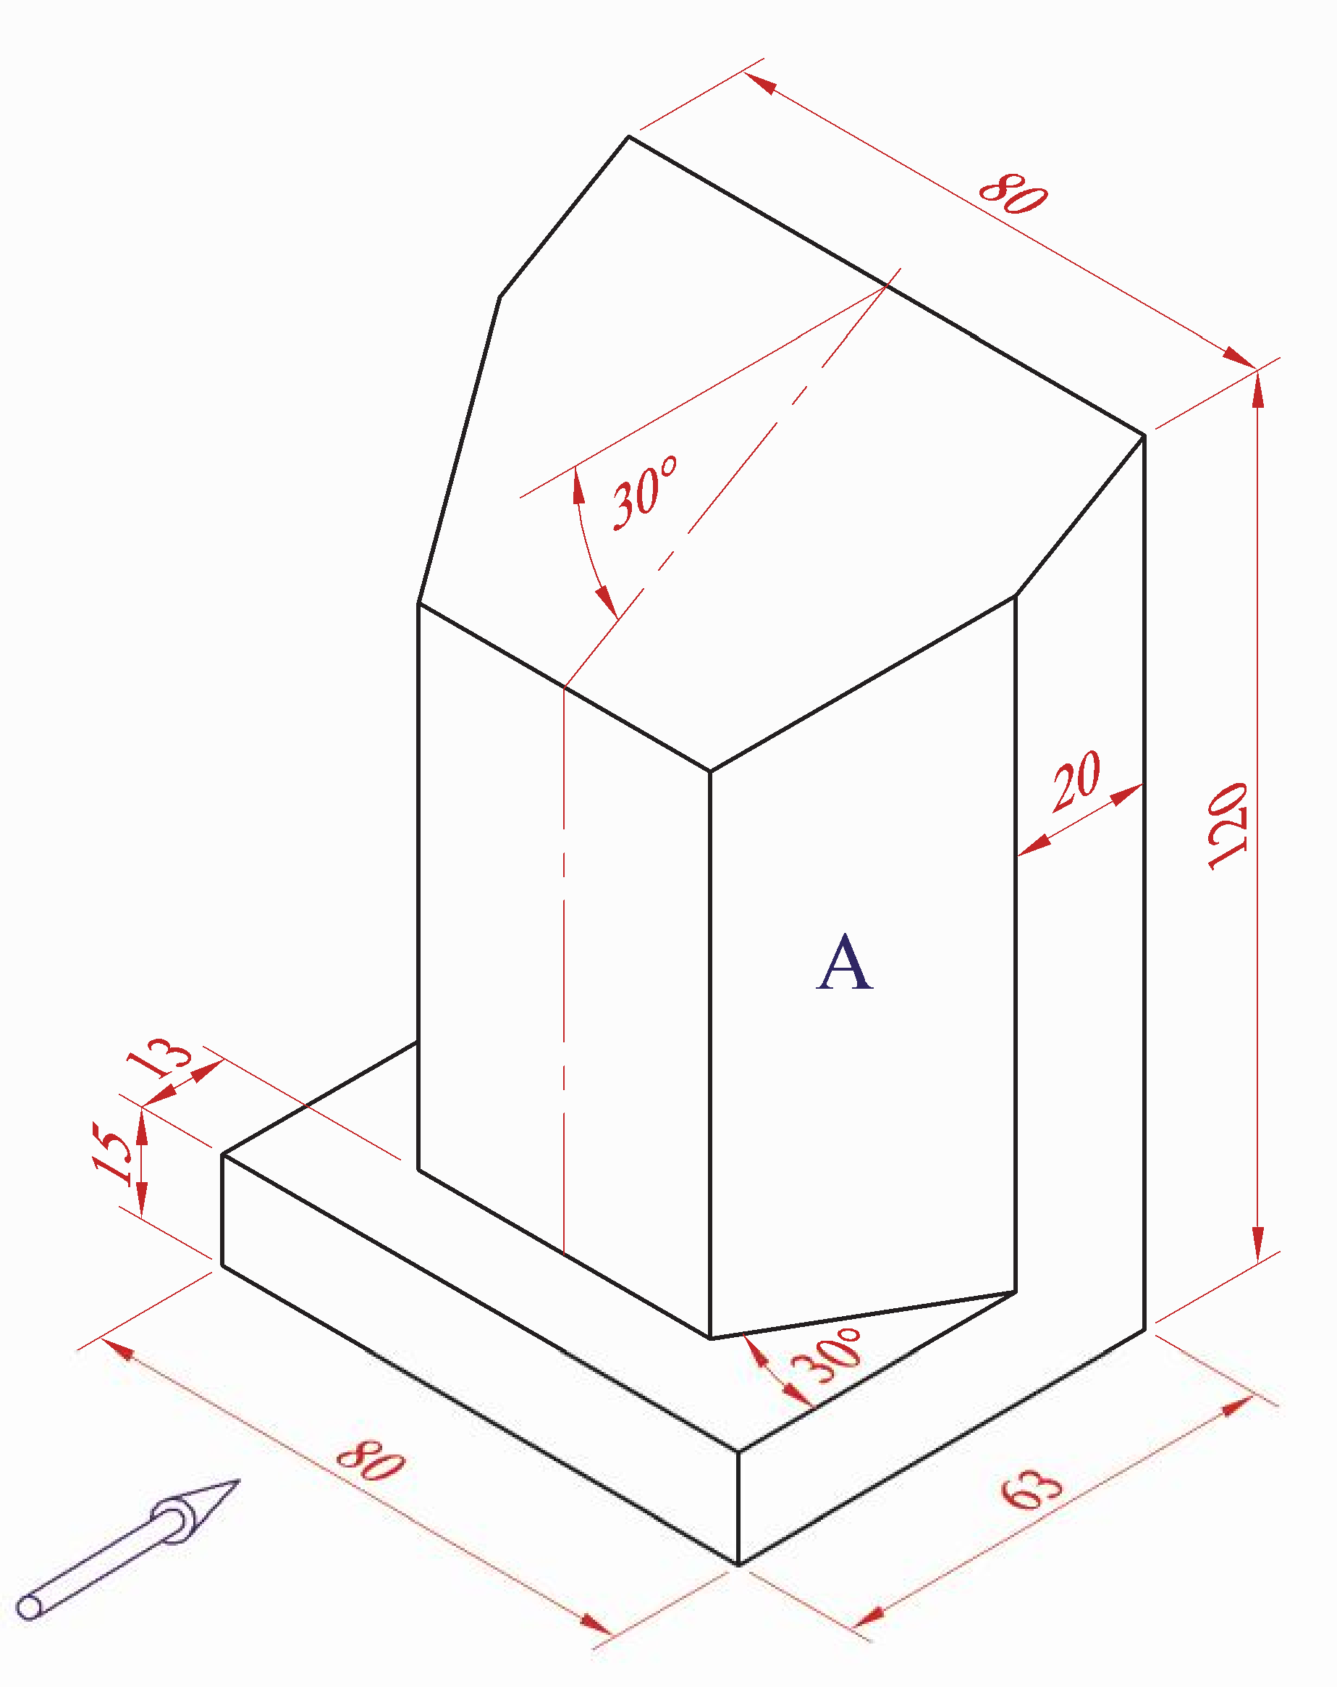

Fig. B-1

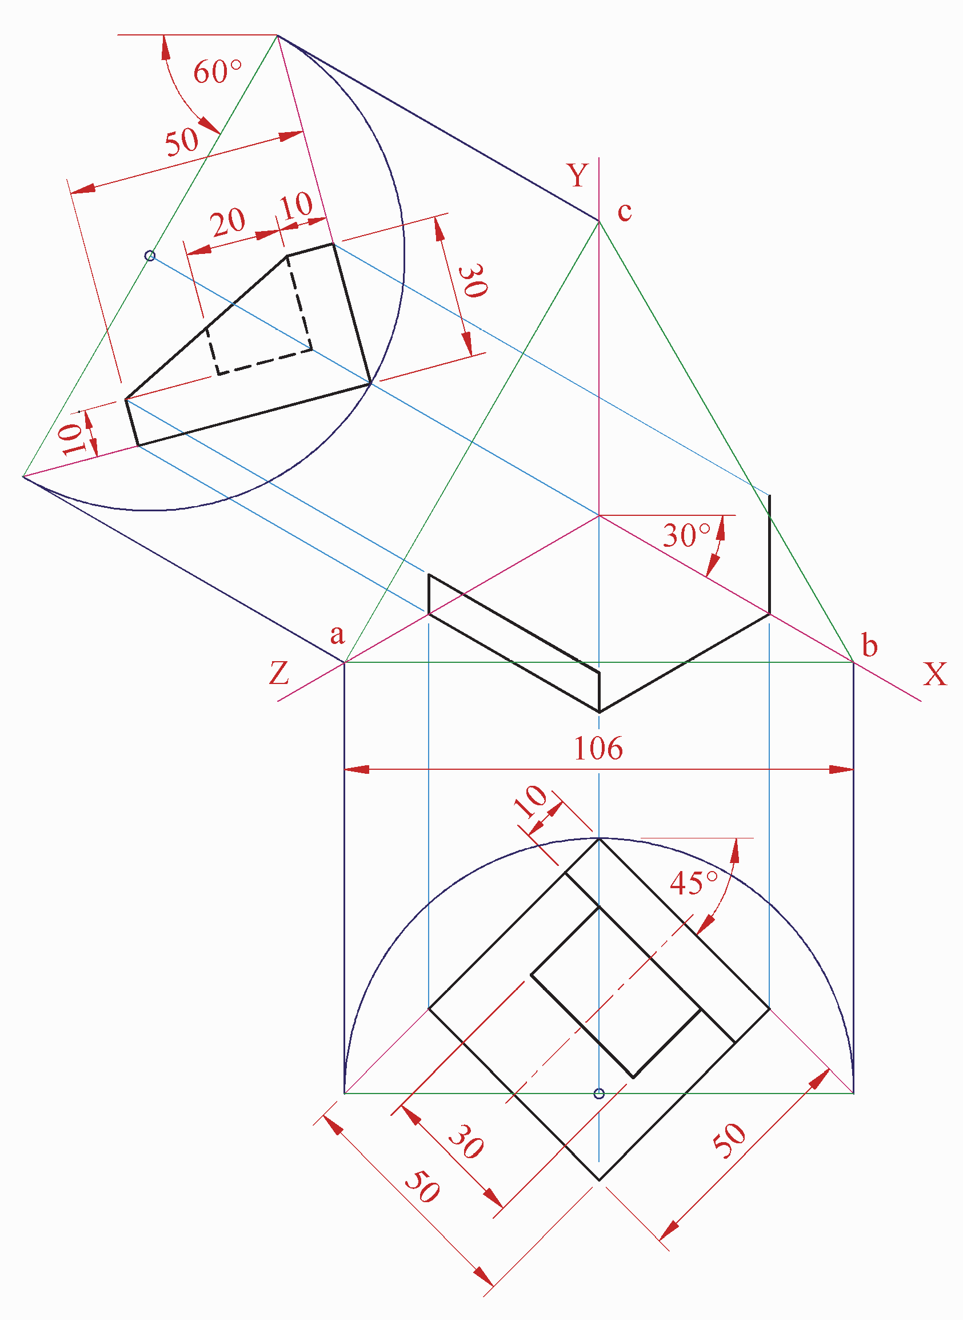
B-2. The 3D graphic on the right shows a unit for holding and charging a cordless phone.
Fig. B-2 shows an incomplete isometric projection of the unit.
The end view and plan of the unit are also shown in their required positions.

- Draw the given equilateral triangle abc and the axonometric axes X, Y, and Z.
- Draw the end view and plan, positioned as shown.
- Draw the complete axonometric projection.

Scale 1:1

Fig. B-2

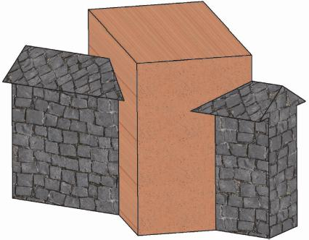
B-3. The 3D graphic on the right shows the intersection of a wall and a pillar.
Fig. B-3 shows the plan and incomplete elevation of the arrangement.
- Draw the given plan and elevation of the structure and show all lines of interpenetration.

- Draw an end view of the structure.

Scale 1:1

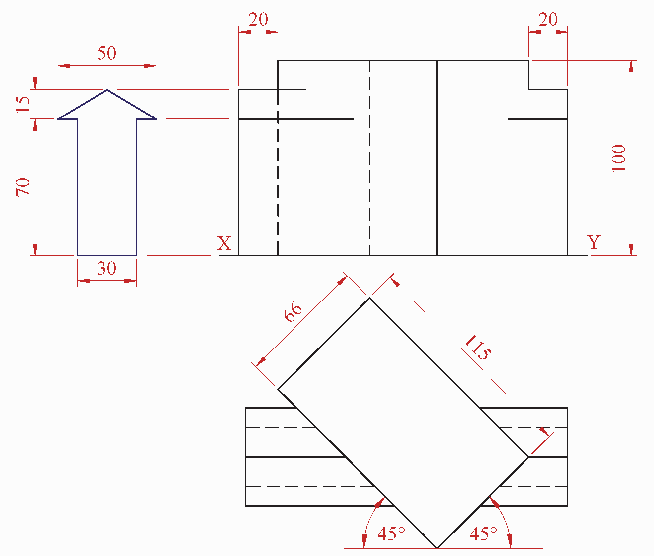

Fig. B-3

Geologic Geometry

C-1. The accompanying map, located on the back page of Section A, shows ground contours at 5 metre vertical intervals.
SECTION C - Applied Graphics
Answer any two questions (i.e. the options you have studied) from this section on drawing paper

  - On the drawing supplied, draw a vertical section (profile) on the line AB.

  - The line CD is the centreline of a proposed level roadway which is at an altitude of 55m.

Using side slopes of 1 in 1 for both cuttings and embankments, complete the earthworks on the northern side necessary to accommodate the roadway.

(Note: The earthworks on the southern side of the roadway have already been completed.)

Scale 1:1000

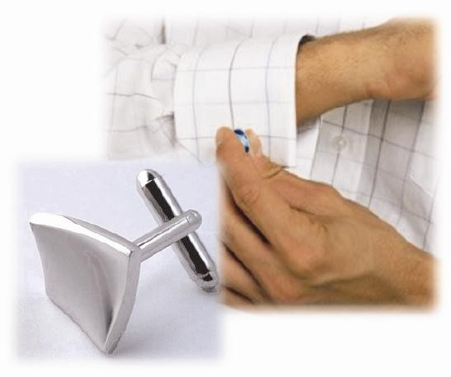
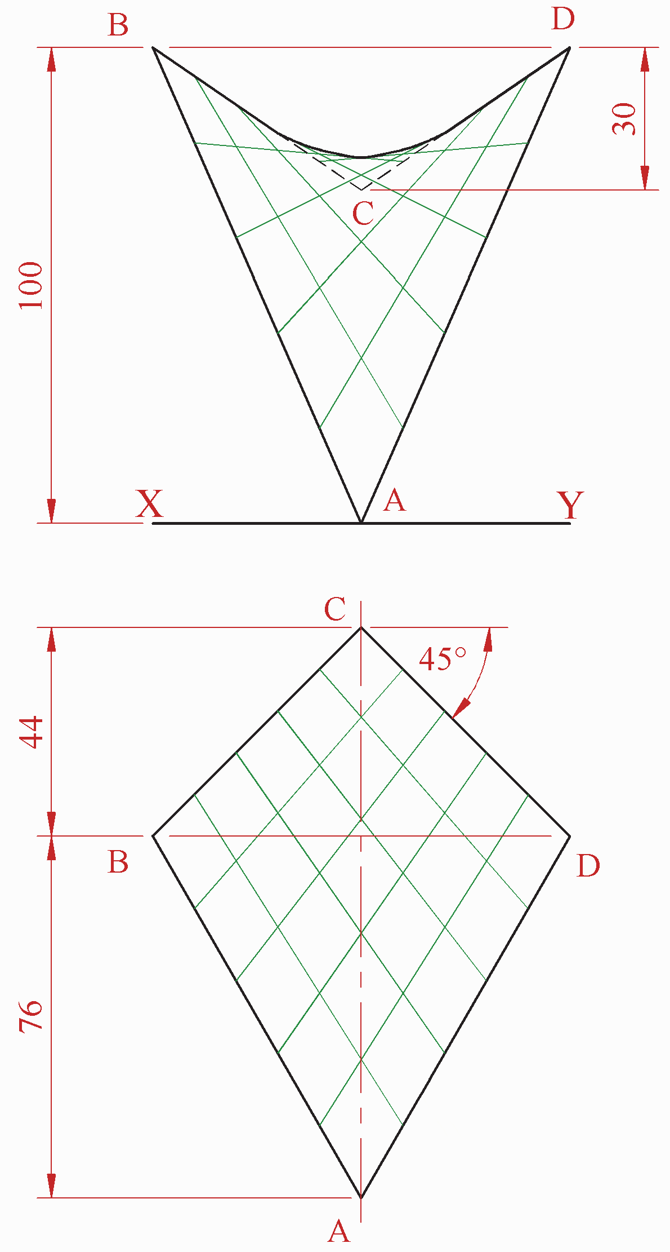

C-2. The 3D graphic on the right shows a cufflink which includes a hyperbolic paraboloid surface.
Structural Forms
Fig. C-2 shows the plan and elevation of a typical hyperbolic paraboloid surface, ABCD.

- Draw the given plan and elevation of the hyperbolic paraboloid surface.
- Project an end view of the hyperbolic paraboloid surface.

Scale 1:1

Fig. C-2

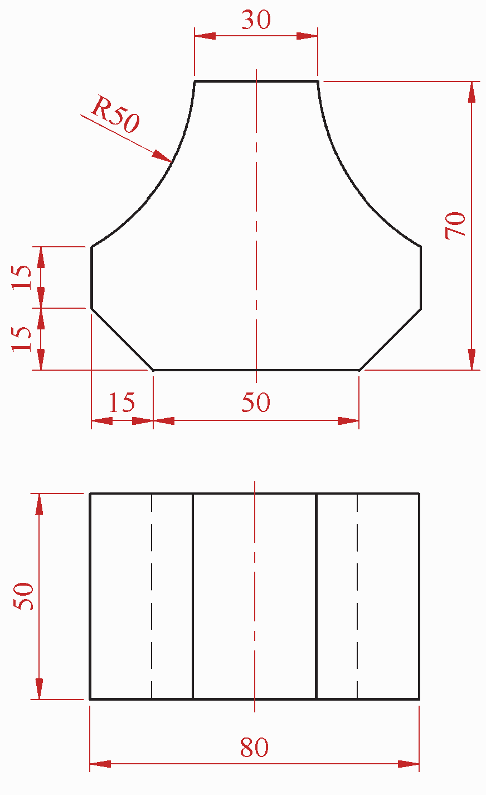
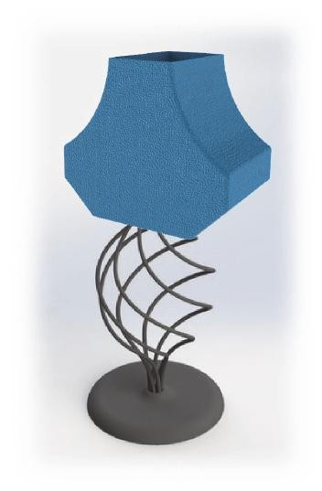
C-3. The 3D graphic on the right shows a table lamp with a modern lampshade. The lampshade is open at the top and at the bottom.
Surface Geometry
The plan and elevation of the lampshade are shown in Fig. C-3.

- Draw the given views of the lampshade.

- Draw a one-piece surface development of the lampshade.

Scale 1:1

Fig. C-3

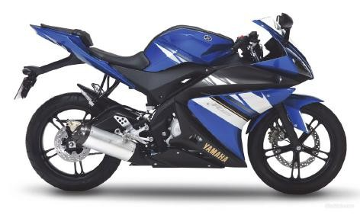
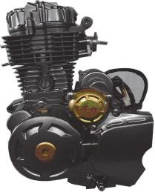
C-4. Cams are used in motorbike engines, like the one shown in the 3D graphic on the right.
Dynamic Mechanisms

Fig. C-4 below shows the outline of such a cam.

The cam imparts this motion to an inline knife edge follower:
• 0° | to | 90° | Rise 50mm with uniform velocity
• 90° | to | 180° | Dwell
• 180° | to | 360° | Fall 50mm with uniform acceleration
 |  |  | and retardation (UAR).

- Draw the displacement diagram for the cam.

- Draw the cam profile given the following:
  - The cam rotates in an anti-clockwise direction
  - The nearest approach of the follower to the centre of the camshaft is 30mm
  - The camshaft diameter is 20mm.

Scale 1:1
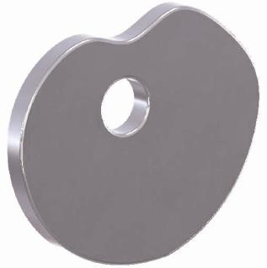

Fig. C-4

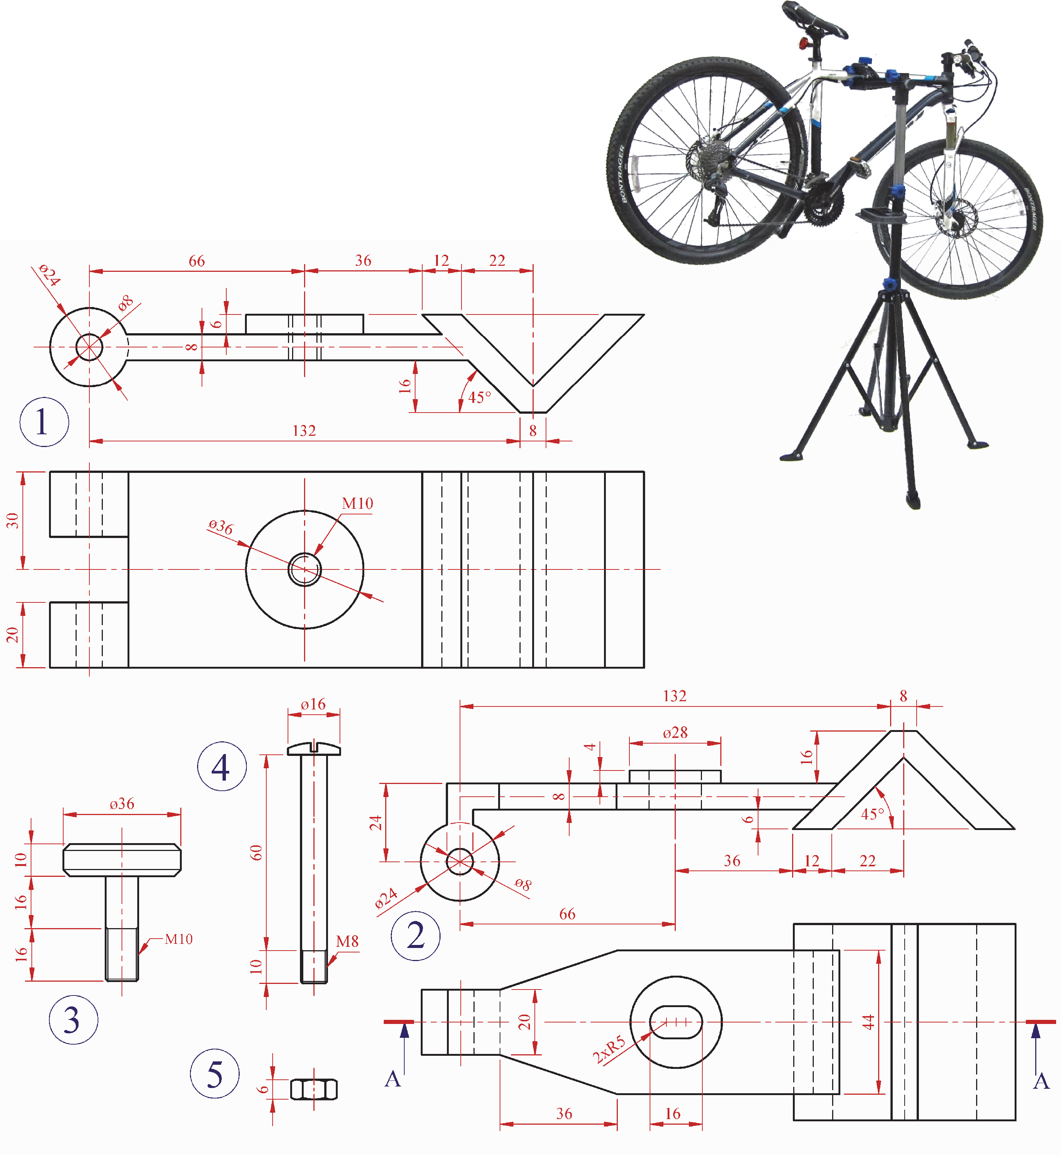
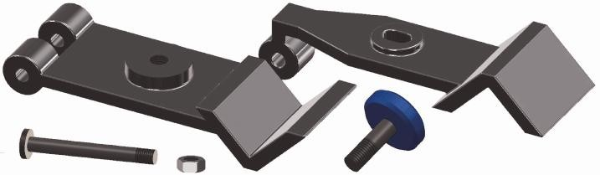

C-5. Details of a Clamp Mechanism from the top of a bicycle stand, as shown on the right, are given in Fig. C-5 below.
Assemblies
A 3D graphic of the individual parts is also shown as well as a tabulated parts list.

Draw the sectional elevation A-A of the assembled Clamp Mechanism.
(All chamfers are 2mm×2mm. Any omitted dimensions may be estimated.)

Scale 1:1

Fig. C-5
Part | Name | Qty.
1 | Bottom Clamp Jaw | 1
2 | Top Clamp Jaw | 1
3 | Clamping Screw | 1
4 | M8 Bolt | 1
5 | M8 Hex Nut | 1

BLANK PAGE

BLANK PAGE

BLANK PAGE

BLANK PAGE

